Dzenis Selmanovic - www.naucidizajin.com - Home Page

Bug 1

Summary: The central image in the Slack group is not cropped correctly.

Description: The logo image in the center of the image in the Slack group is not cropped correctly.

Steps to reproduce:

1. Go to the page: [www.naucidizajin.com](http://www.naucidizajin.com)
2. Scroll down to the Slack group

Actual result: The images are of decent size, but the central image with the logo is not nicely cropped

Expected result: All images should be properly cropped and sized.

Reproduced on: Redmi Note 10 Pro, Android, Mi Browser, 1080x2400

Priority/Severity: P4/S4

Bug 2

Summary: Satisfied users | Excessive content has too much space and User Impression is misaligned

Description: The background of the satisfied users section extends beyond the page frame. Also, the user's comment is not properly centered. It would be desirable if the comment was centered on the left page under the section 98.5%.

Steps to reproduce:

1. Go to the page: [www.naucidizajin.com](http://www.naucidizajin.com)
2. Scroll down to the section satisfied users.

Actual result: The container goes outside the page frame and creates too much space. Also, the comment is not nicely centered.

Expected result: All sections should line up and be properly centered.

Reproduced on: PC, Win 10, Mozilla, 1920x1080

Priority/Severity: P4/S4

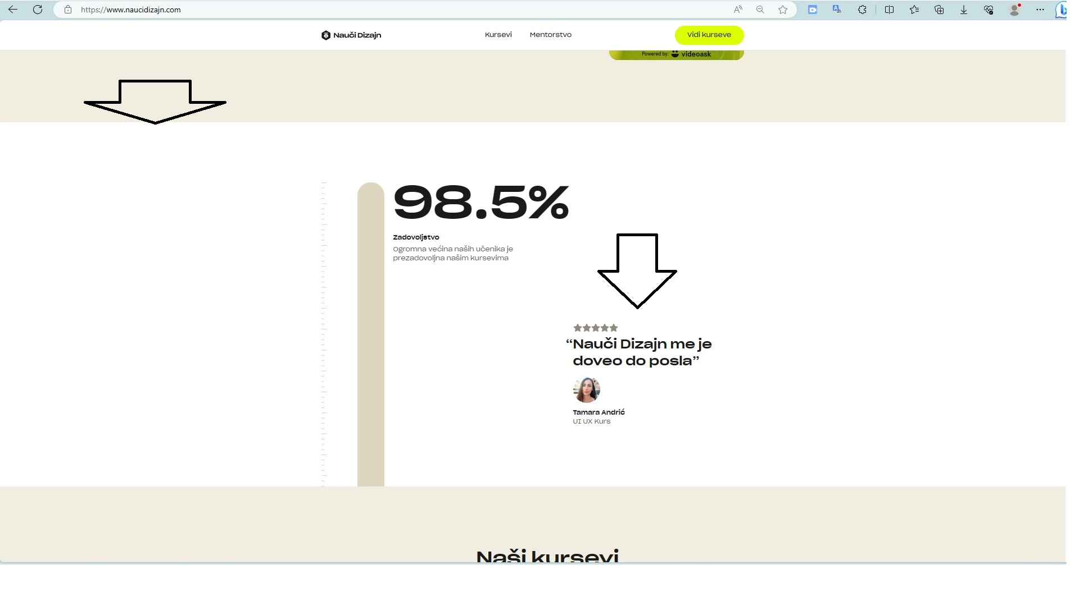

Bug 3

Summary: The title overlaps the Navigation menu on the Home page.

Description: When scrolling down 2-3 times, the title and the Navigation menu overlap. Where after the 4th turn down the scroll returns to normal.

Steps to reproduce:

1 . Go to the page: [www.naucidizajin.com](http://www.naucidizajin.com)

2. Scroll down with the mouse cursor 2-3 times.

Actual result: At the very beginning, when we scroll down, the title overlaps the navigation menu.

Expected result: The navigation bar must not overlap any text on the page.

Reproduced on: PC, Win 10, Mozilla, 1920x1080

Priority/Severity: P4/S4

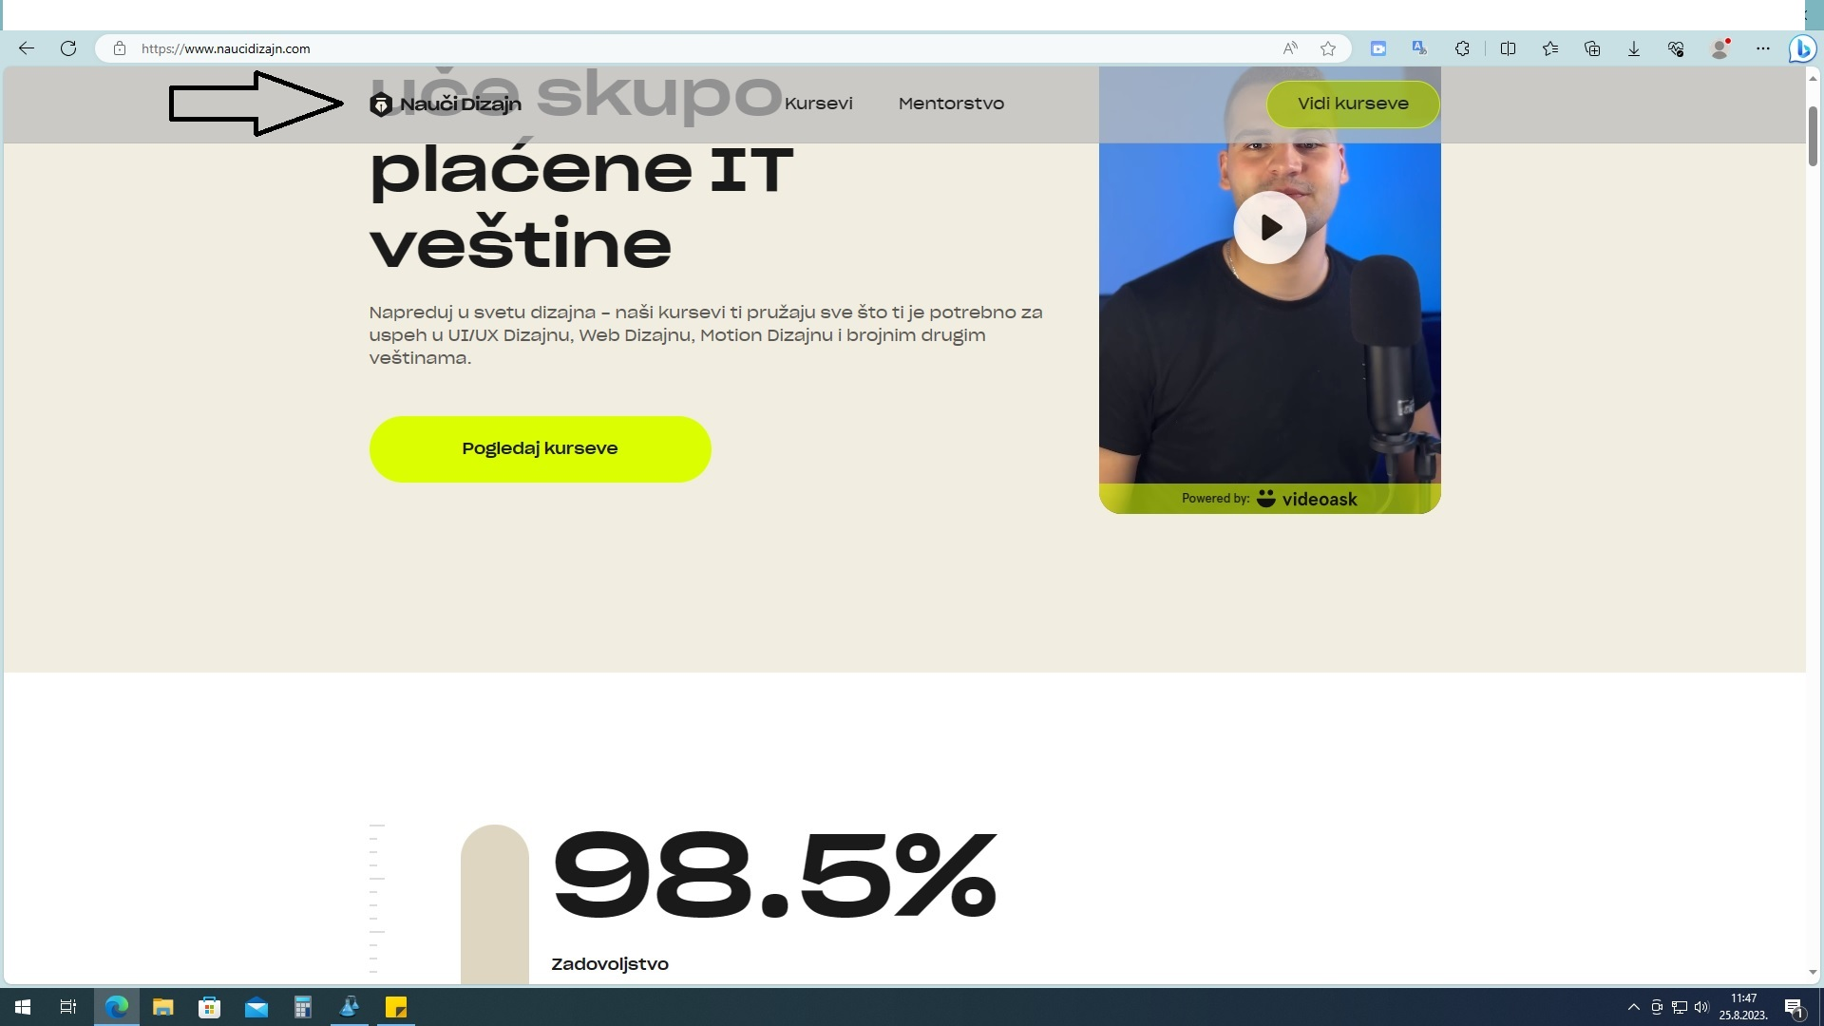

Bug 4

Summary: The page is not responsive for iPad Pro.

Description: The page is not responsive for iPod pro devices and scrolling and overlapping of the page and text occurs.

Actual result: The chaotic appearance of the page was caused because the page is not responsive for the iPod Pro device.

Expected result: The page is responsive for Ipod Pro and there is no shifting of content or overlapping of text.

Reproduced on: Win 10, Brave

Priority/Severity: P3/S2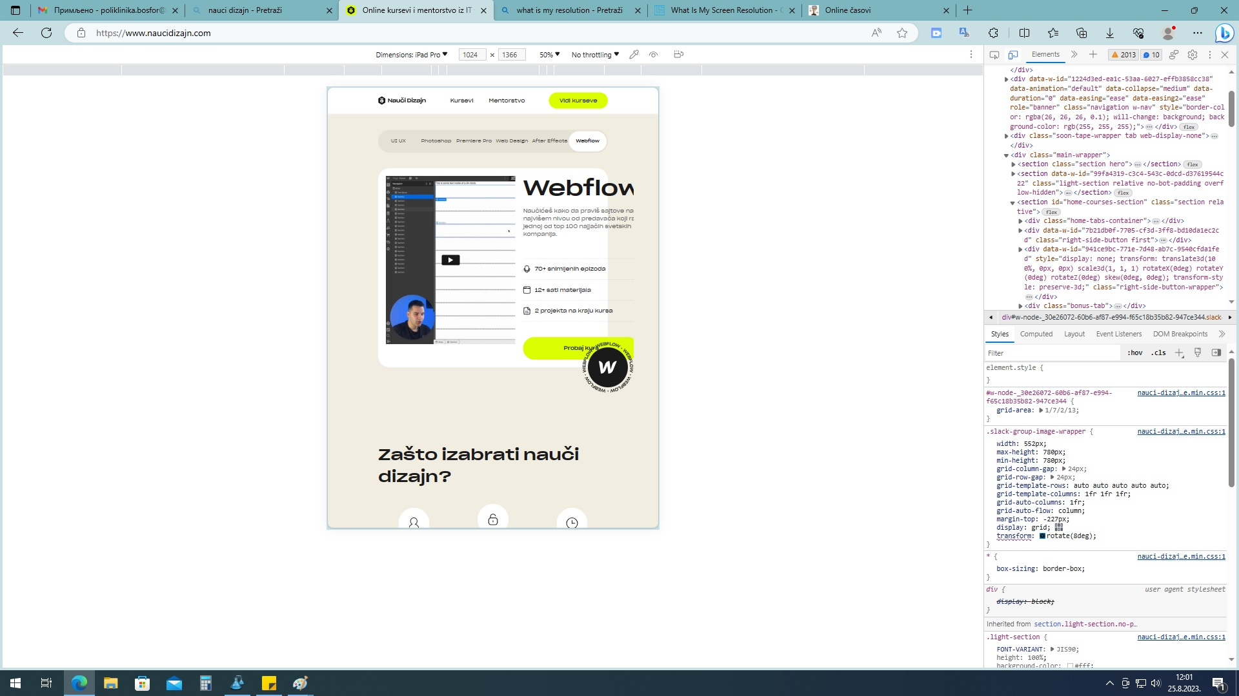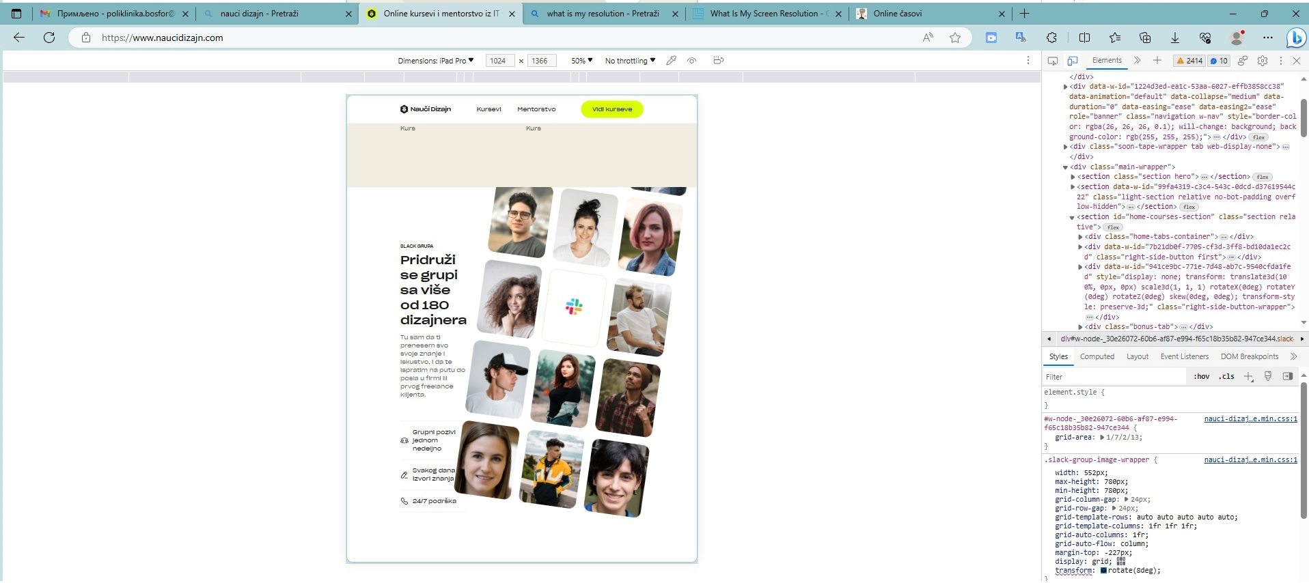

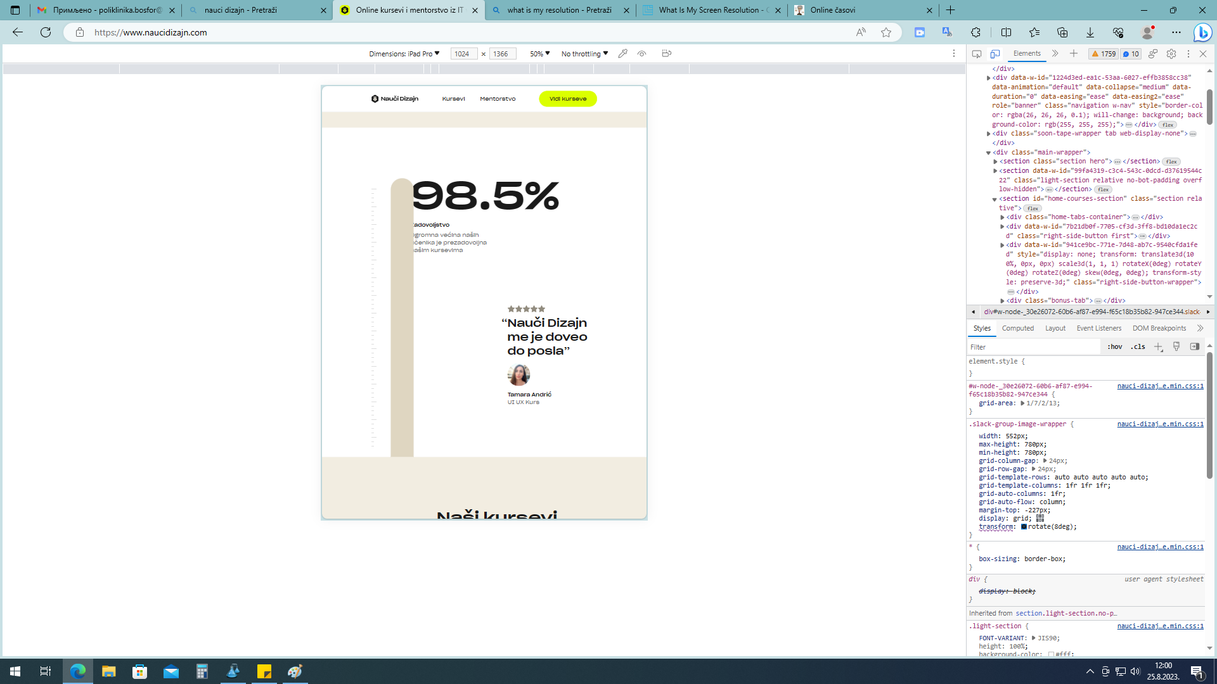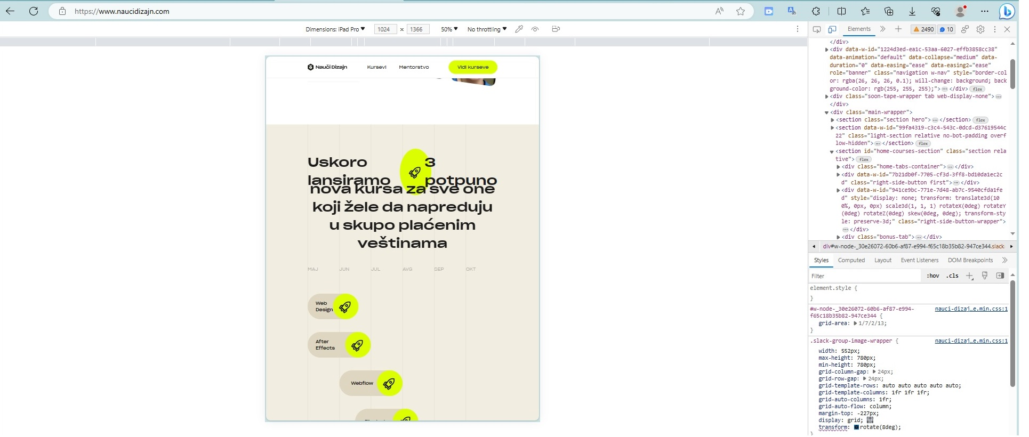

Bug 5

Summary: Slide scroll blog section. The images are not the same size and the ‘Read’ button is out of line.

Description: The size of the images is not the same, an unnecessary empty space is created between the images and the ‘Read’ button falls out of line. Adjust the size of the image and text so that the ‘READ’ button is in line.

Steps to reproduce:

1. Go to the page: [www.naucidizajin.com](http://www.naucidizajin.com)
2. Scroll down to the section side scroll Blog.
3. Actual result: The size of the images is not the same and the ‘Read’ button is out of line. The images are not the same size, therefore the Read button is not in line.

Expected result: The size of the images must be the same and the text below must be in line.

Reproduced on: Win 10, Brave

Priority/Severity: P4/S4

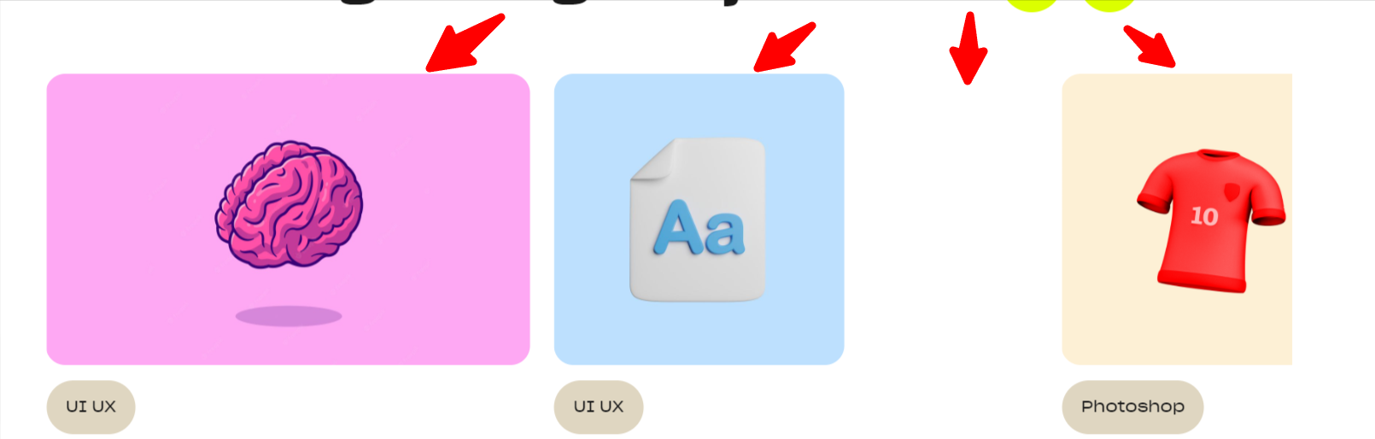



Bug 6

Summary: Lack of a full stop at the end of the sentence.

Description: Lack of full stop at the end of some sentences.

Actual result: Some sentences on the Home page do not have a full stop at the end.

Expected result: The page must be graphically accurately written.

Reproduced on: Win 10, Brave

Priority/Severity: P4/S4

